|  |  |
| --- | --- |
| Ex No: 3  Date: 21/08/2024 | Building Deep Neural Networks for Distributed Applications |

**Objective:**

The primary objective of this project is to design, build, and implement deep neural networks for distributed applications, leveraging the capabilities of L-layer neural networks. The project aims to develop a comprehensive framework for training neural networks efficiently across distributed systems.

**Descriptions:**

This project involves the creation and training of deep neural networks using a variety of layers and activations. The focus is on implementing a multi-layered approach to improve model accuracy and scalability when applied in distributed environments. The notebook guides through initializing parameters, forward propagation, backward propagation, and parameter updates for both two-layer and L-layer neural networks.

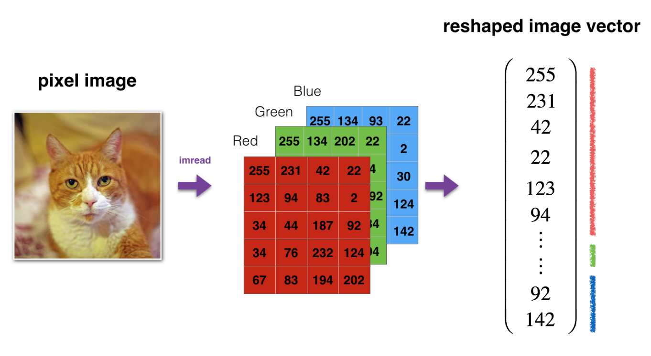

**Model:**

The project builds and trains two primary models:

* Two-layer Neural Network: A simple neural network with two layers designed to perform basic tasks.

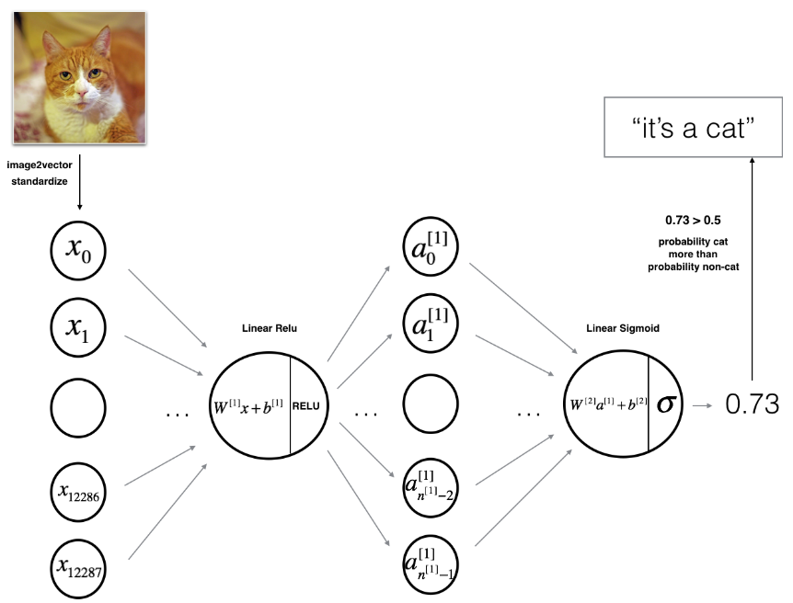

* L-layer Neural Network: A more complex, deeper network that involves multiple layers to capture intricate patterns in the data.

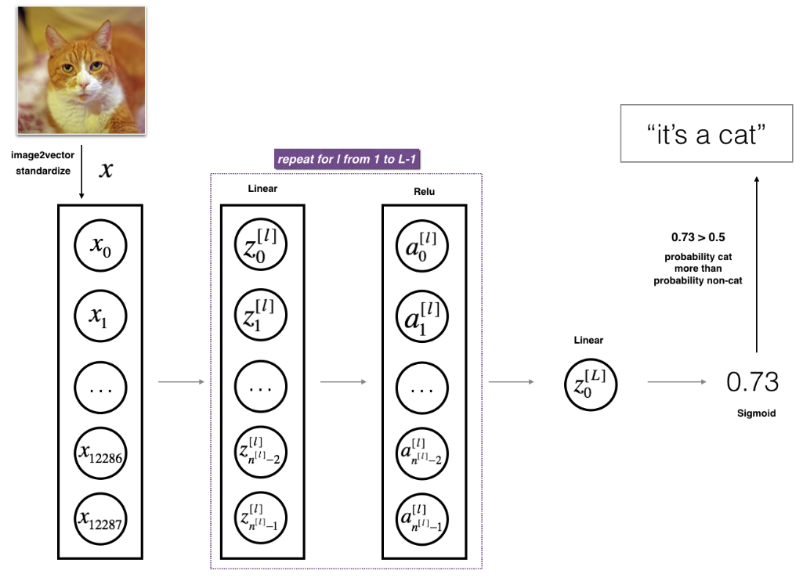

**Building the parts of algorithm:**

The development process includes several key steps:

1. Initializing Parameters: Setting up the initial weights and biases for the network layers.
2. Forward Propagation: Calculating the output of each layer using linear and activation functions.
3. Cost Function: Measuring the error of the network's predictions against the actual outcomes.
4. Backward Propagation: Calculating the gradients to update the parameters by backpropagating the error through the network.
5. Parameter Update: Adjusting the parameters using gradient descent to minimize the cost function.

**Accuracy:**

* Two-layer Neural Network:
  + Achieved a test accuracy of 72% on the Cat vs Non-Cat classification task.
  + The model performed better than a logistic regression baseline which had a test accuracy of 70%.
* L-layer Neural Network:
  + Achieved a test accuracy of 80% on the same classification task.
  + The training accuracy for this model was approximately 98.56%, showing strong performance on the training data.

**Result Analysis:**

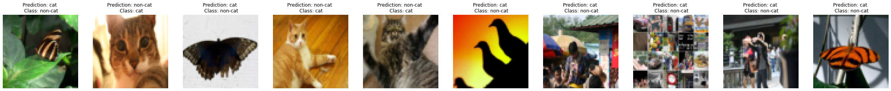

**Summary:**

* The project successfully implements and tests the performance of deep neural networks on distributed systems. The networks are designed to handle complex tasks, with a clear demonstration of the learning process and parameter tuning. The L-layer model, in particular, shows significant promise in handling more challenging datasets by capturing deeper insights.

**Approach of How We Are Solving:**

* The approach adopted involves breaking down the task of building a deep neural network into smaller, manageable components. Each component is implemented as a helper function, and these functions are integrated to form the complete network. The project emphasizes modularity, ensuring that each part of the network can be easily modified or extended. The training process is iterative, involving regular updates to the network parameters based on the observed performance.

**GitHub Link:**

https://github.com/Mithungowda6666/Deeplearning/tree/main/Lab3_2